**Day 07**

**User Administration**

**Definition**

**User administration involves managing individual user accounts on a system,including tasks such as Creating Modifying and deleting user accounts, setting password policies,assigning permissions and privileges to users.**

**1.User and Passwd will Creating**

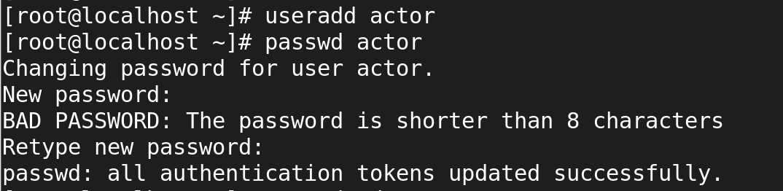**2.Passwd will removing**

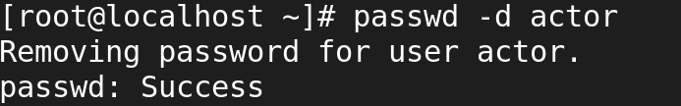**3.Passwd has been Changing**

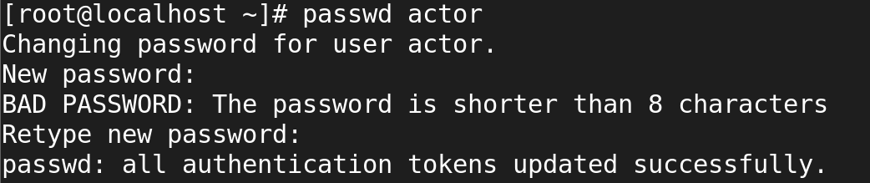**4.Passwd has been Locking**

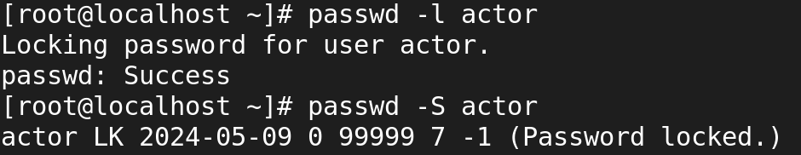

**5.passwd has been unlocking**

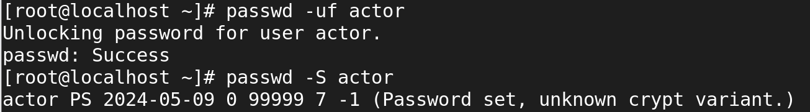

**6.User information has been Checking**



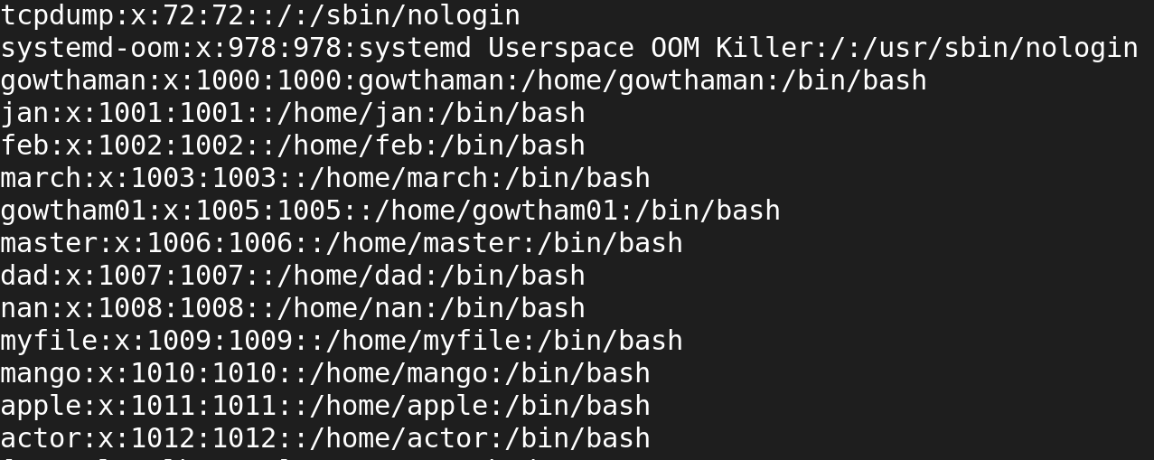

**7.passwd information has been Checking**



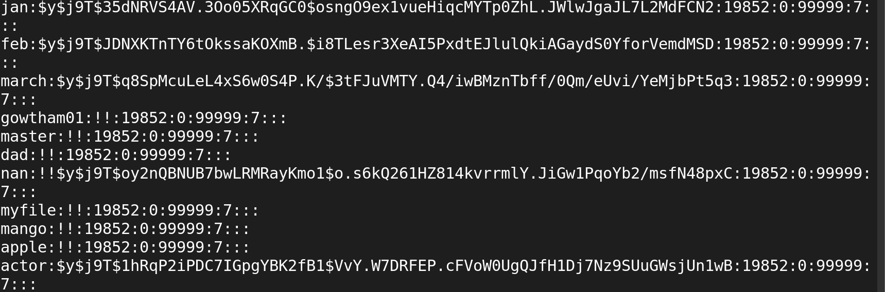

**8.To delete an users account with its home directory and mail directory**



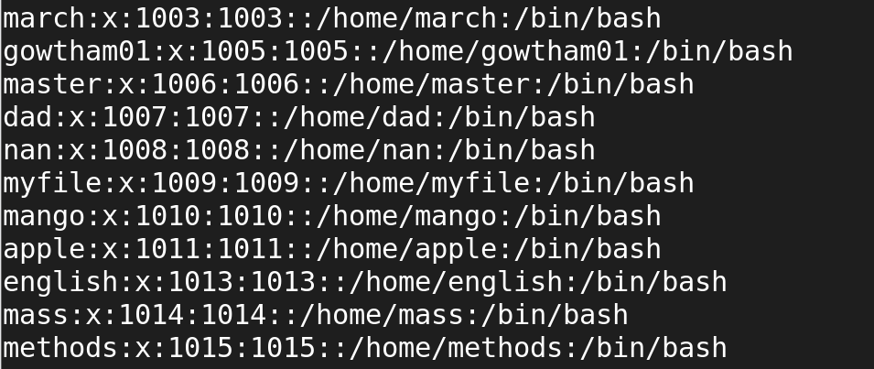

**amma:x:1019:1019::/home/amma:/bin/bash**

**Username: amma**

**Passwd ref to shadow:x:**

**Uid: 1019**

**Gid :1019**

**comment:**

**Home dire:/home/amma:**

**Login shell : /bin/bash**

**Change the uid**

**1.usermod -u 4545 amma**



**2.groupmod -g 4545 amma**



**3.command -c today amma**



**4.usermod -d directory has been changed**

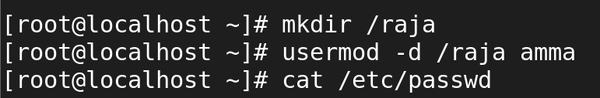



**5.usermod -s shells has been changed**



